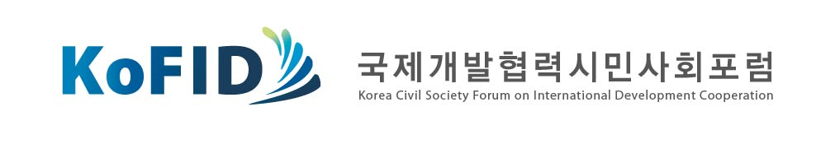

Statement on the biased public opinion survey commissioned by MOSF on ODA policies

31 March 2013

● The survey which induces a negative perception on ODA lacks objectivity and fairness
● The MOSF should openly explain the current situation where public opinion was distorted wasting tax payer’s money
● Any polls on the ODA should be conducted in a independent and objective manner with substantial participation of CSOs and non-governmental experts.

MOSF has conducted a Gallup-commissioned public opinion research survey on the ODA(Official Development Assistance)and KSP(Knowledge Sharing Program) in cooperation with KDI and issued a press release of the results on the 18th of March. This press release was reported by various major papers presenting a negative public perception on the necessity of ODA.
Upon thorough examination by KoFID(Korea Civil Society Forum on International Development Cooperation) of the questionnaire it was found that the statements of the questionnaire have been written in a manipulating way. For example, answer items included statements such as ‘Simple financial aid through grants does not contribute to development of developing countries’ and ‘more governmental budget should be placed into the ODA sector regardless of the government’s financial difficulties or existence of domestic poverty’ implying that providing grants causes a waste of tax money while offering loans is a more reasonable way of assistance. Considering that now many donor countries are expanding grants and write-offs of loans based on the recognition that loans can bring negative effects on poverty eradication in partner countries by placing excessive burden of debt repayment on them, the answer items were definitely prepared against the international trend and standards. It is also regretful that the questionnaire induces antipathy to government’s spending on ODA by mentioning financial difficulties or the existence of domestic poverty since the Korean government has already made a commitment to the international society to increase the ODA budget up to 0.25% by 2015. The answer items should have informed respondents that the scale of the Korean ODA budget is far below OECD average (0.31%).
In addition, the press release issued by MOSF contains arbitrary interpretation that does not appear in the results of the research. That is, groundless analysis such as “The majority of people preferred loans which place emphasis on ‘ownership’ of the partner country” was added in the summary of the result of the survey. This is worrisome as it can mislead readers to consider that offering loans is the only way to ensure ownership of the partner countries while promoting ownership is a general principle that should be complied with throughout any ODA implementations. In fact, about 70% of loans that the Korean government offers to partner countries are tied aids which compel them to use Korean goods and services damaging the ownership. For this reason, OECD DAC suggested that Korea strike manageable and appropriate balances between grants and loans and translate the commitment to untie 75% of its total bilateral ODA by 2015 into a year-on-year road map.
KoFID cannot help but doubt the purpose and the intention behind the survey conducted by MOSF and KDI and express grave concerns over such lack of objectivity and equity. We are also concerned regarding the survey and the press release of MOSF that is driving public opinion against ODA policies and especially ODA in the form of grants.
Korea has received a great deal of attention internationally. KoFID strongly urges that all governmental bodies put an effort to address the current situation through close cooperation, where MOSF seeks to establish arbitrary loans-oriented ODA policy by manipulating public opinion. Furthermore, more effort should be made to advance ODA activities and form a social consensus on the importance and necessity of ODA in order to meet international standards including the Paris Declaration on Aid Effectiveness and the Busan Global Partnership.

Korea Civil Society Forum on International Development Cooperation (KoFID)

Child Fund Korea, World Vision Korea, Climate Justice Institute, COPION, Global Civic Sharing, Good Neighbors, Korea Association of International Development Cooperation(KAIDEC), Korea Center for United Nations Human Rights Policy(KOCUN), Korea Food for the Hungry International(KFHI), Korea Green Foundation, Korea Human Rights Foundation, Korea NGO Council for Overseas Development Cooperation(KCOC), Korean House for International Solidarity(KHIS), Korean Women’s Association United(KWAU), National Council of YMCA Korea, ODA Watch, One body One Spirit(OBOS), People’s Solidarity for Participatory Democracy(PSPD), Planned Population Federation of Korea(PPFK), Re-shaping Development Institute(ReDI), Save the Children Korea, Asian Bridge, Transparency International Korea(TI-Korea), World Together

For further information or inquiries, please contact Ms. Doun Moon, Program coordinator, Korea Civil Society Forum on International Development Cooperation at +82 (0)2 2279-1706, Kofid21@gmail.com. http://www.kofid.org.

